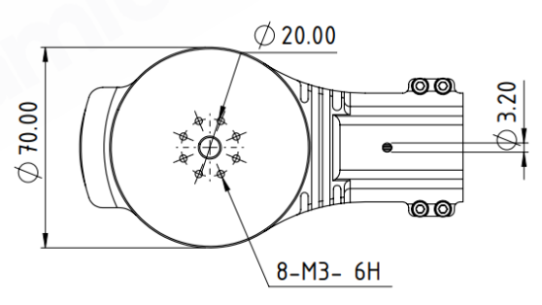
DM-S70 Drone Motor
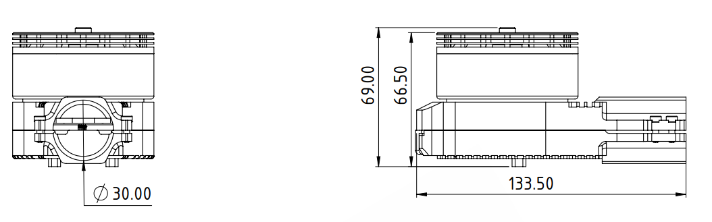
Basic Motor Parameters
Throttle | % | 60
Max. Thrust | kg | 12
Recommended Takeoff Weight | kg | 4-6
Torque | Nm | 1.45
KV Rating | rpm/V | 150
Bus Voltage | S | 12-14 S
Operating Current | A | 20
Rated Speed | rpm | 4400
Propeller Force Efficiency | g/W | 8.7
Electrical Parameters
Number of Phases |  | 3
Number of Poles |  | 28
Terminal Resistance Phase to Phase | mΩ | 35
Terminal Inductance Phase to Phase | mH | 40
Thermal Data
Ambient Temperature | °C | -40...+85
Max. Winding Temperature | °C | +155
Physical Parameters
Outer Diameter | mm | 70
Shaft Diameter | mm | 8
Weight | gr | 0.760
Motor Connection
U | RED
V | BLACK
W | WHITE
Sensor Connection
N/A | N/A
Connector Articles
Power | N/A
Signal | N/A
Propeller Info (Recommended)
Diameter | 24”
Pitch | 7.2”

